Equation and Inequalities- Questions
May 2018 Mathematics Advanced Paper 1: Pure Mathematics 1

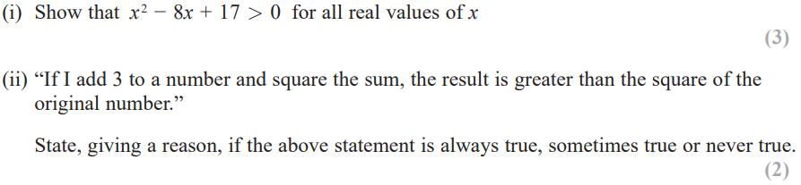

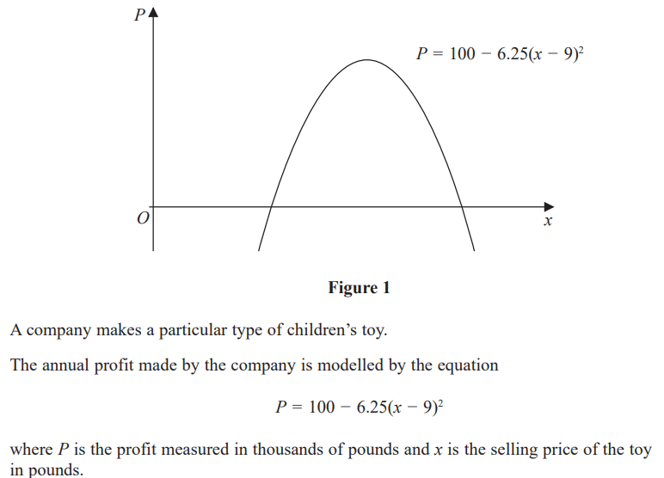
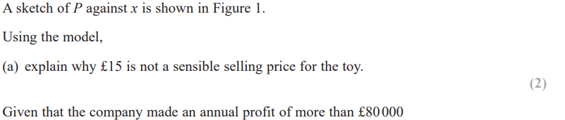
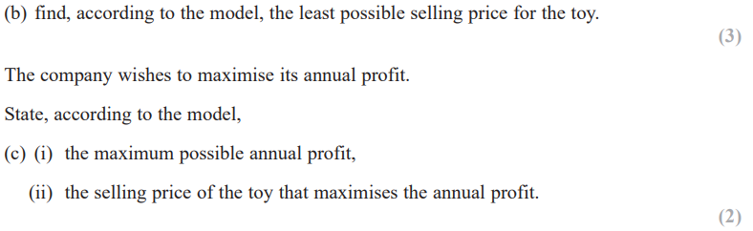

May 2016 Mathematics Advanced Paper 1: Pure Mathematics 1

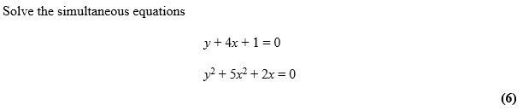
May 2015 Mathematics Advanced Paper 1: Pure Mathematics 1

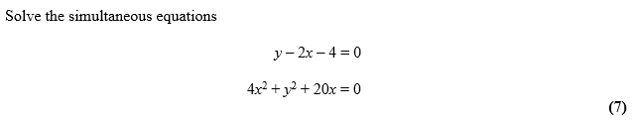
May 2014 Mathematics Advanced Paper 1: Pure Mathematics 1

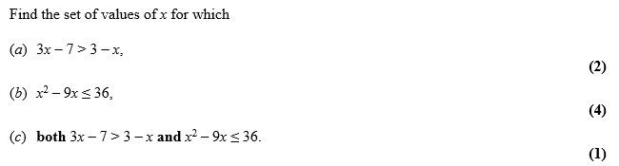

May 2013 Mathematics Advanced Paper 1: Pure Mathematics 1

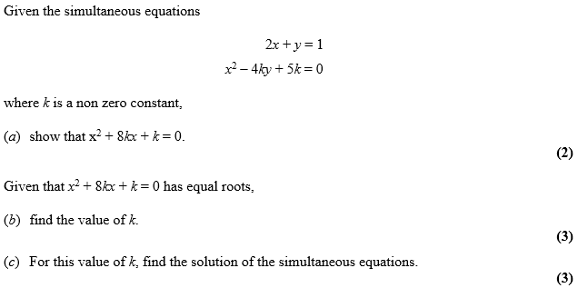

Jan 2012 Mathematics Advanced Paper 1: Pure Mathematics 1

May 2011 Mathematics Advanced Paper 1: Pure Mathematics 1

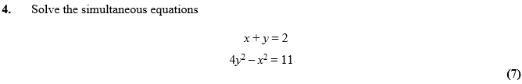
May 2010 Mathematics Advanced Paper 1: Pure Mathematics 1

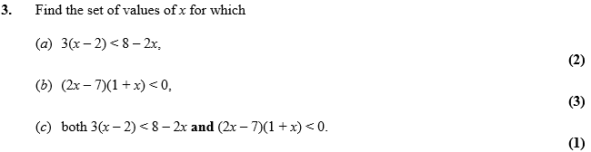

Jan 2010 Mathematics Advanced Paper 1: Pure Mathematics 1

